Quarch Technology Ltd

AN-017

Application Note

QPS automation with FIO

For use with:
All Streaming Power Module
Quarch Power Studio (QPS)

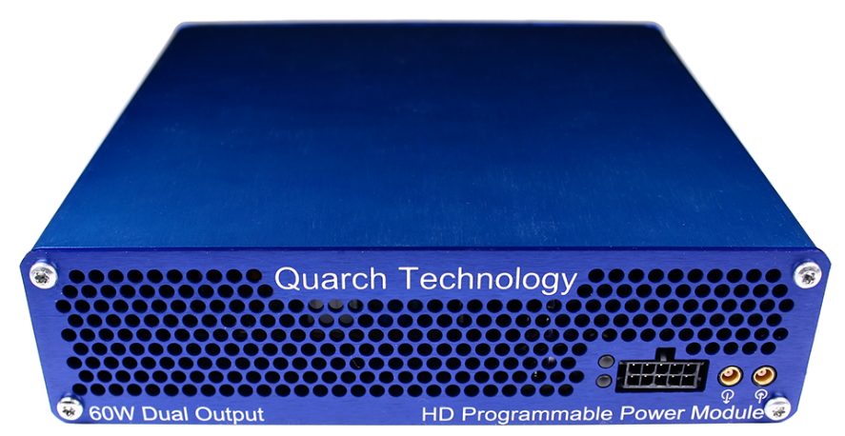

Change History
1.0 |  | Initial Release
1.1 | Feb 2019 | Updated to Python 3.x
1.2 | May 2019 | Updated for quarchpy 2.x
1.3 | October 2020 | Minor fixes and improvements to script output
1.4 | March 2023 | Improved commenting, bug fixes and error checking

Contents
Change History 2
Introduction 4
Modules Supported 5
System Supported 5
Application Note Example Files 5
Installation and setup 5
Python install 5
QuarchPy library install 6
Java install 8
QPS install 8
FIO install 8
Power module setup 9
Running the example 10

Introduction
Quarch Power Studio (QPS) is a unique system for recording and analyzing power consumption of storage devices. This application note demonstrates the ability to automate QPS and bring in user data from another source. In this example, FIO is used to drive traffic to a device and plot both power and performance as part of a fully automated test.

Examples of Modules Supported
XLC power modules
- QTL1824 (QTL1824-02A modules do NOT support streaming, but can be upgraded by Quarch)
- QTL1847
HD power modules
- QTL1995
- QTL1999
PAM
- QTL2312 - With all power measurement fixtures.
All streaming power modules should be accepted but may not be listed here.

Power module setup
Connect the power module to the test PC and the output of the power module to the drive under test.

Customer Drive
USB/LAN Connection
Power Module
Customer Test PC

Running the example
QuarchPy ships with scriptFIO.py and supports two forms of integration with FIO:
- If you wish to use FIO without a file, you can populate the variable arguments with valid FIO arguments and the user will be prompted to select a target folder from a GUI window.
- For the users familiar with FIO configuration files, QuarchPy is able to import all settings from a .fio file.
The scriptFIO.py file demonstrates both options in sequence.
Before running this example, make sure you have a valid .fio file (as described in FIO’s manual) and its path is declared as the variable fioFile. You can use the jobFileExample.fio file provided with AN-017.
The variable arguments should be populated with valid FIO arguments (as described in FIO’s manual).

- You will be prompted to select the Quarch power module you want to connect to.
- If the power module’s outputs are disable, you will be prompted to enter a voltage mode (3V3 or 5V). If they are on from a previous run, the script will proceed.
- You will be prompted to enter an averaging rate. Pressing enter should use the default value of 32k.
- You will be prompted to select a target folder to run on, ensure that you select the correct drive (the one connected to Quarch’s power module), or the FIO test may erase important data!
- The script will now launch Power Studio, this may take a few seconds
- The script will iterate through every job described in the .fio file or the arguments variable.
- As each FIO run is executed, the script will:
  - Display the real time power consumption.
  - Annotate the start and end of each test.
  - Parse the FIO results and add the second-by-second performance data onto the chart.
